Food
burger | chips | apple | bread
bananas | sandwich | chocolate | honey
cake | biscuit | eggs | cheese
fish | ice cream | pizza | orange juice
milk | chicken  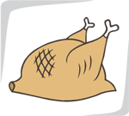 | sausage  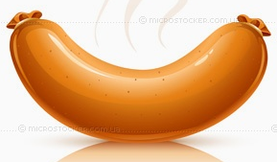 | fruit  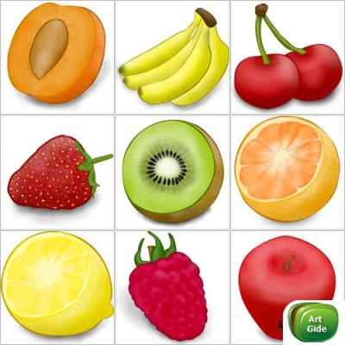
carrots | potatoes | tomatoes | vegetables  